Manuscript Title – Bold, 14pt, Times New Roman, Centre text
Author Name One^{1*}, Author Name Two², Author Name Three^{1[ORCID]}
¹ Department Name, University Name, City, Country
² Research Institute Name, University Name, City, Country
corresponding_author@email.com
Abstract. The abstract should be a single, structured paragraph containing 200 to 300 words at 9pt size. It must succinctly outline the core aspects of the study: (1) Background/Context: State the research problem and significance briefly; (2) Objective: Formulate the exact aim of the present study; (3) Methods: Summarize the experimental planning, laboratory procedures, or specific national/international standard criteria employed (e.g., TCVN, ASTM); (4) Results: Provide definitive statistical or qualitative findings, specifying clear directional parameters or percentage adjustments; and (5) Conclusion: Synthesize recommendations or specific material utilization thresholds deduced from the outcomes. Do not cite literature or references in this section.
Keywords: keyword one; keyword two; material property; technical standard; maximum 5-6 descriptive keywords.
- Introduction
The introduction should establish a rigorous theoretical and practical foundation for the study. Authors must delineate the background context, outline the broader engineering or technical significance, and state the targeted limitations of conventional materials or frameworks. Clearly review recent domestic and global historical literature to explicitly highlight the research gaps. Introduce the specific additives, parameters, or innovative methodologies under test. Conclude the introduction section by explicitly stating the specific objective of this paper. In-text citations must follow the standard numeric format enclosed in brackets, for example: [1], [2,3], or [4-6].
- Research Method
This section must comprehensively detail the experimental setup, raw materials, properties, and analytical methods used so that the research can be reproduced accurately. Specify the geographical origins, basic configurations, and precise technical characteristics of all testing components (e.g., aggregate distribution, density, chemical composition, manufacturer details).
  - Technical Standard, Criteria, Table, Figure
Explicitly cite all regulatory criteria and test procedures. Standard specifications must follow official notation rules, such as TCVN XXXX:YYYY for Vietnamese national standards or ASTM XXXX for American standards. Avoid descriptive generalities; instead, list exact curing conditions (e.g., testing ages at 3, 7, 14, and 28 days), sample geometries (e.g., 150mm x 300mm cylindrical specimens), and concrete grade definitions.
Ensure each batch design includes clear naming conventions that correspond precisely with the figures and tables in the results section. The formatting requirement for structured numerical data is demonstrated in Table 1 below.
Table 1. Mineral composition of material [4].
Type of Material | Content (%)
 | SiO₂ | Fe₂O₃ | Al₂O₃ | CaO | Na₂O | K₂O | MgO | MKN
Cement | 21.49 | 3.49 | 5.40 | 63.56 | 0.15 | 0.7 | 1.4 | 1.2
Silica fume | 93.45 | 0.52 | 0.92 | 1.57 | - | - | - | 4.20
- Experimental Results and Reviews
Present results chronologically or analytically with full descriptive narratives. Do not simply replicate the numerical values visible in your figures; instead, analyze the underlying trends, mechanics, and cross-correlations. When displaying charts, figures, or laboratory photographs, center the item and place a dedicated caption directly beneath it as shown in the placeholder below. Discussion must explicitly evaluate why variations occurred. For instance, explain why a given dosage alters workability, causes strength reduction, or impacts structural retardation by linking the macroscopic observation to microscopic chemical interactions, surface effects, or micro-crack propagation mechanisms. Benchmark your findings directly against relevant baseline data from the introduction.

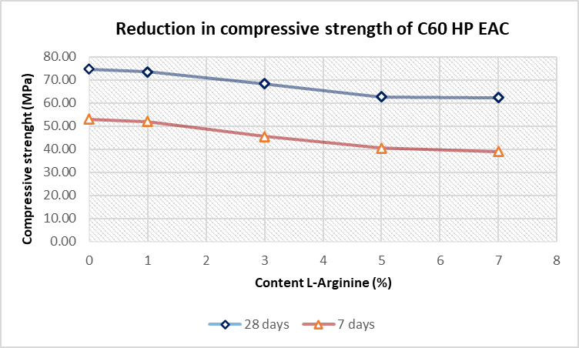
Fig. 4. The decrease in compressive strength of C60 HP EAC samples with L-Arginine content.
- Conclusion and recommendations
Provide clear, numbered or bulleted conclusions that directly answer the core research questions. State the optimized quantitative limits or thresholds derived from the study (e.g., recommended material selection boundaries or specific mix proportions). Conclude with explicit, actionable recommendations for future engineering applications or structural design implementations.

Acknowledgments

Acknowledge any funding bodies, university laboratories, technical councils, or material suppliers who provided direct support for the research project

References
- Author, A. B., Author, C. D.: Title of the referenced article. Journal Name Volume(Issue), Page numbers (Year).
- Author, E. F.: Title of the referenced book or academic thesis. Publishing House / University Name, Location (Year).

